Business Loan Report

In total, there are 1830607144 in authorization and 766599993 in outstanding, which is less than half of the authorization.

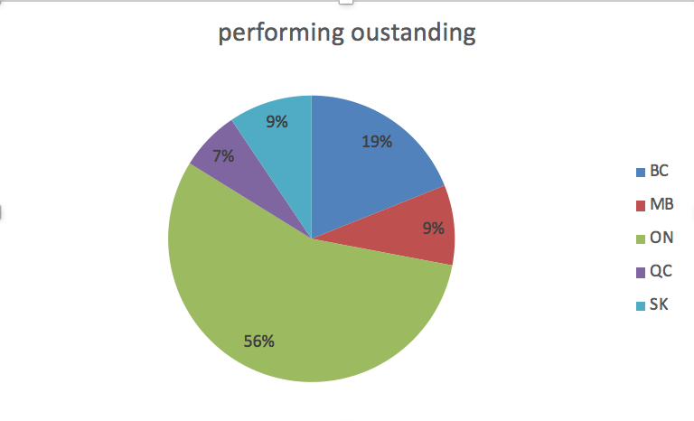

In term of performing, there are 56% outstanding coming from ON, 19% coming from BC, and the rest ,25%, is from MB, SK, and QC. However for the impaired percentage, there are 58% from ON and 21% from SK.

We can see that, as for the loan in Ontario, the impaired rate is higher than the outstanding rate by 2%. It is better to decrease the impaired rate .

In SK, the outstanding is only 9%, while the impaired rate is 21%, which is more than double the outstanding rate. We should decrease the authorization amount in SK or we should do more risk analysis for the client from SK.

In MB ,the performing rate is relatively high, 97%. The default rate has stayed low since mid-2015 and remained stable , which is good.

However, all of our wirte-off,206100 outstanding, is from MB. This is a risk for us. So we should be analyze more before we invest in MB

The line graph shows an upward trend for the outstanding in default in QC and SK. So we had better to analyze carefully in the future if we plan to invest in these two provinces.

we can invest more after further analysis in BC .Because the performing is relatively high,98% Moreover, the default outstanding started to go down at the end of 2014 and stayed at a low level in 2015. In MB, it has stayed low since mid-2015.And both of them is stable. So it is a good opportunity for us to invest in them ,especially BC.

In short, for ON, its better for us to reduce default rate. As for SK and QC, we should do more analysis before we invest. But it’s a good chance for us to invest in BC.